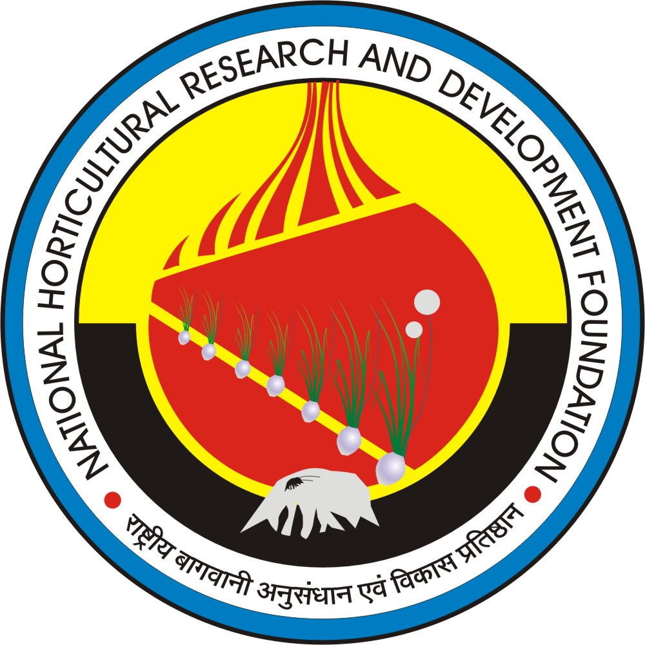राष्ट्रीय बागवानी अनुसंधान एवं विकास प्रतिष्ठान
NATIONAL HORTICULTURAL RESEARCH AND DEVELOPMENT FOUNDATION
Bagwani Bhawan, D-47, Pankha Road, Institutional Area, Janakpuri, New Delhi-110058
Phone no-011-28524150/28522211 Fax No-: 011-28525129
E-mail:delhi@nhrdf.com Website: www.nhrdf.org

APPLICATION FOR NHRDF AWARD-2020

BIO-DATA OF APPLICANT
1. Name in Full (in block letters): (Surname followed by first and second name) |  |  | Paste recent Passport size color photograph here.
2. Date & Place of Birth (Village/ District, State ) :
3. Nationality:
4. Present Position/Designation and the period since the present position is held. Retired applicants may mention last position held. |  | :
5. Full Address:
Correspondence Address: |  | Permanent Address:

Educational and Professional Qualifications: (Self-Attested copies of certificates and mark sheets should be enclosed with application)

Level | Year of Passing | Name of Institute/University | Specialize Subject(s) with major field | Division/Grade/  Marks/Percentage | Remarks, if any
Graduation
Masters
Ph. D.
Professional qualifications

- (a) Employment record (starting from the present position):
Designation | Pay Scale | Major discipline of work experience | Nature of work | Organization/ Institute | Place of posting | Period
 |  |  |  |  |  | From (DD/MM/ YYYY) | To (DD/MM/ YYYY)

(b) Total Years of experience : (YYYY/MM/ DD) _ _ _ _ _ _ _ _ __

No. of training programmes attended:
Duration | Title | Name of institution that Organized training | Duration of training programme
 |  |  | From  (DD/MM/YYYY) | To  (DD/MM/YYYY)

- Recognition & Awards:
Category of Recognition/ Award | field of Recognition/ Award | Year | Awarding organization

- Capacity development and collaborative programme:

Type of programme | Program details | Institution | Co-ordination / associate | Duration

11: Externally Funded Projects:

Title of the project | Level of Association (PI/CoPI) | Period |  | Value of the project (Rs. in lacs) | Sponsoring agency
 |  | From (DD/MM/YYYY) | To (DD/MM/YYYY)

- Special attainments of the nominee, if any.
Teaching:

Research:

Extension:

- List of Fellowships, Awards & Honours

i. International Fellowships/Awards/Appreciation:
ii. Honours/Awards by Central Govt. Organizations/ Institutes e.g. (ICAR, DST, DBT)
iii. Awards by the State Government, Universities and Deemed to be Universities
iv. Young Scientist Awards/Associate-ship by the National Science Academies
v. Best Teacher/Researcher/Extension Worker Award
vi. Best Research Paper/ Poster Award (Indicate details)
vii. Positions in Societies:

Concepts/Processes/Patents/Products/Technologies & Books related to Onion and Garlic
(To be limited in the space provided)
I. Concepts, Processes, Patents and Varieties:
II. Products and Technologies:

IV. Impact on Society of Varieties/Technologies With Socio-Economic Relevance:

III. Adoption Area of Varieties/Technologies Developed in Onion & Garlic:

V. Important Books/ Bulletins/ Chapters A) Books

  - Bulletins:

  - Reports:

  - Chapters:

  - Editorial Members:

- Research Publications: (NAAS rating more than 5) in the descending order of NAAS score of the Journals indicating name of author(s), year of publication, title, name of the journal, volume No. and page Nos.

Sl. No. | Publications  (Authorship, year, title, journal, Vol. No., pages, etc. as per style of Indian Journal of Agriculture Science) | NAAS  rating on 2021 basis
1

2
3

4

5
6

7

8
9

10

- Draft for Citation (if selected)

- Applicants are requested to enclose all necessary self-attested certificates.

- The application should be sent through proper channel only.

OR
- Through any one of the following societies member

  - Indian Society of Horticulture
  - India Society of Vegetable Science.
  - Indian Society of Alliums

- Applications must be sent in the prescribed format available on website, otherwise, applications shall not be considered.

Declaration

I declare that no vigilance/disciplinary proceedings are pending against me and the information given above is true to the best of my knowledge and, if found false, the above award shall be withdrawn from me in future or action will be taken against me.

Place: Signature

Date: Full Name:

NOMINATION FOR NHRDF AWARD-2020
(All entries in the nomination form should be typewritten.
The required information/particulars should be given in the space provided)
The undersigned hereby propose………………………………………………………………….
as a candidate for selection as an Awardee for NHRDF Award-2020.

Remarks about the nominee’s suitability indicating whether the remarks are based on personal or general knowledge.
Name of Proposer Present position Signature
Date

Place

--- ***---

