Report of
“Scientific Beekeeping Training Programme”

Sponsored by
National Bee Board
Department of Agriculture, Cooperation & Farmers Welfare
Ministry of Agriculture and Farmers Welfare, Govt. of India
“B” Wing, IInd Floor, Janpath Bhawan, Janpath, New Delhi
2021-22
20

Through

ICAR - Agricultural Technology Application Research Institute,

Zone-II, Jodhpur (Rajasthan)

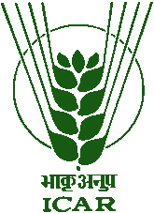
Organized by
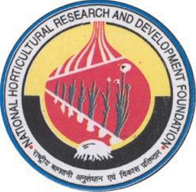
Krishi Vigyan Kendra
(National Horticultural Research & Development Foundation)
Nafed Complex, Village & post: Ujwa, New Delhi – 110 073
Ph. No. 9667971155, e-mail:
kvkujwa@yahoo.com
Website: www.kvkdelhi.org

